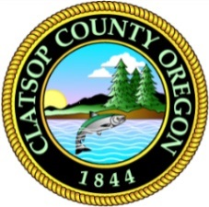
1100 Olney Ave.
Astoria, OR 97103
(503) 325-8631 phone / (503) 325-9312 fax
www.co.clatsop.or.us
Clatsop County
Public Works

JEWELL STORAGE BUILDING PROJECT 2024 BID RESULTS
APRIL 16, 2024

Wickwire Contracting LLC $386,268

ATK Construction Inc. $498,000

Helligso Construction Co. $488,042

Paramount Ironworks $610,765

Wickwire Contracting LLC is the apparent lowest bidder

