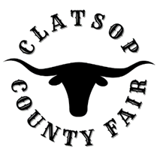
Board Meeting Agenda
November 1, 2022
board Members Present
Mike Autio, Chair
Kallie Linder, Vice Chair
Jack Ficken
Brittany Israel
Matt Bellingham
Jason Brim – Interim Manager
Call to Order
Roll Call
Public Comment – At this time anyone wishing to address the Fair Board concerning items of interest not already on the Agenda, may do so. The person addressing the Fair Board will, when recognized, give their name and address for the record. All remarks will be addressed to the whole Board and limited to 3 minutes per person. Fair Board members reserve the right to delay any action, if required, until such time when they are fully informed and the matter is scheduled as an agenda item.
Consideration of past Minutes from October 4th 2022 meeting
Old Business
- Update on Concert Artist Options
New Business
- County Memorandum of Understanding
- 4-H Campground Policy
- Capital Improvements
- Going Digital with Admissions
- OFA Report and Convention Feb. 2-5
  - WFA Convention Jan. 15-18
Financial Statement
Board/Staff Communications Pending Contracts and Fees
Report from County Commissioner Courtney Bangs
Adjournment

