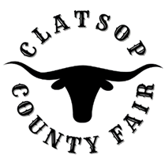
Board Meeting
October 4, 2022
board Members Present
Mike Autio, Chair
Kallie Linder, Vice Chair
Jack Ficken
Brittany Israel
Matt Bellingham

Jason Brim – Interim Manager
Call to Order
Consideration of past Minutes
Public Comment - At this time anyone wishing to address the Fair Board concerning items of interest not already on the Agenda may do so. The person addressing the Fair Board will, when recognized, give their name and address for the record. All remarks will be addressed to the whole Board and limited to 3 minutes per person. Fair Board members reserve the right to delay any action, if required, until such time when they are fully informed and the matter is scheduled as an agenda item.
Business Items
- LOCO
- Fair and Concert 2023
Managers Update
- Facility - Fire/alarm systems brought up to code and compliance.
- On Call Services
Financial Statement
Round Table Discussion
Report from County Commissioner Courtney Bangs

