Budget & finance

Memorandum

To: Department Directors

From: Monica Steele

Date: January 23, 2023

Subject: Indirect Cost Plan 2023-24

As you look at your indirect costs for the 2023-24 fiscal year, it is important to note that indirect costs are real costs to the County and the allocation of these costs to the funds utilizing these services is a necessary practice to illustrate the true cost of programs. These costs represent the expenses of doing business that are not readily identified with a particular grant, contract, project function or activity, but are necessary for the general operation of the organization and the conduct of activities it performs. The total program cost is not only important within the County, but it is our fiduciary and ethical duty to represent true cost accounting to the public.

Over the past five fiscal years the General Fund has recovered the following amount in overhead costs as well as the amount that is being budgeted to recover in the 2023-24 FY:

- $1,101,400 in 2019-2020
- $1,174,900 in 2020-2021
- $1,307,700 in 2021-2022
- $1,460,400 in 2022-2023
- $1,678,900 in 2023-2024

The County’s indirect cost plan includes the amounts to be budgeted in your 2023-24 budgets. Each indirect cost packet comes with the allocation plan comparison and allocation unit comparison, table of contents, summary of total costs per department, and the cost plan detail. The cost plan uses the term “Central Service” department to refer to the County’s overhead departments and the term “Grantee Department” to refer to the receiving departments. The County’s cost plan has 11 central service departments; Equipment Use Charge, Board of Commissioners, County Administrator, Employee Relations, County Counsel, Public Information Officer, Finance & Treasury, Information Systems, Records, Building & Grounds and Miscellaneous. All other departments are referred to as “Grantee Departments”. Below is a detailed list of items included in the packet.

Table of Contents: Lists the different sections of the cost plan summary and detail pages.

Allocation Plan Comparison: Details out the 2022-23 indirect cost amounts per department and compares them to the prior year amounts. In addition to the Plan Comparison of Detailed Allocated Costs which is a report that does a two-year comparison based on central service department allocation units per department. This report is helpful when analyzing why your department’s indirect costs increased or decreased.

Allocated Costs By Department: Shows each org. unit with the amount of allocated expenses per service department. Gives a total cost per org. unit that matches your Allocation Plan Comparison.

Summary of Allocated Costs: Displays the expenditures for each central service department and for each grantee the allocations made to it.

Summary of Allocation Basis: Lists all of the allocation basis used in the plan.

Costs to be Allocated: Summary of costs to be allocated for each central service department.

Costs Allocated by Activity: This report provides greater detail than the “costs to be allocated” report by breaking the expenses out into functions and showing how much each function will allocate. The report also displays how each central service department allocated its costs, both direct and incoming.

Allocation Summary: This schedule recaps the allocations by department and activity. The report lists the departments which have received allocations down the left, and the activity across the top.

Please feel free to contact Jennifer Carlson should you have any questions or concerns regarding your cost plan.

Thank you,

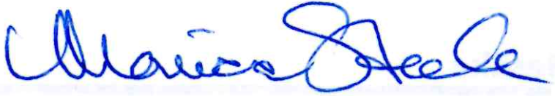

Monica Steele
Assistant County Manager

