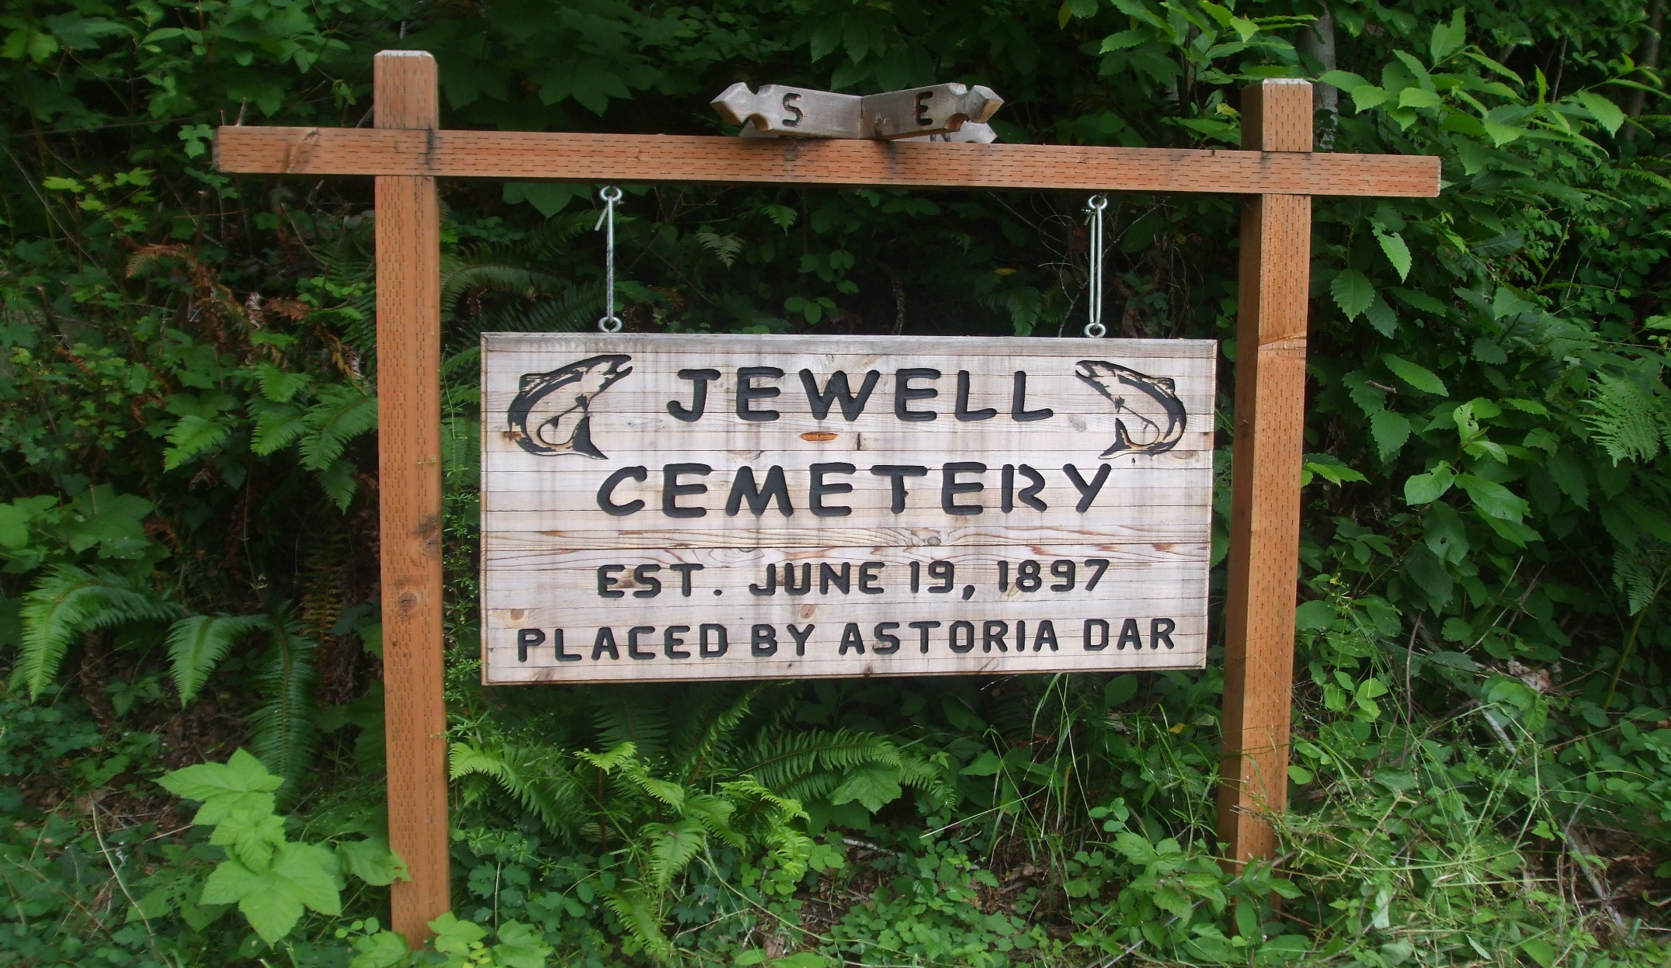
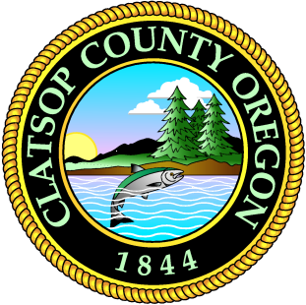
2040
ELSIE-JEWELL COMMUNITY PLAN
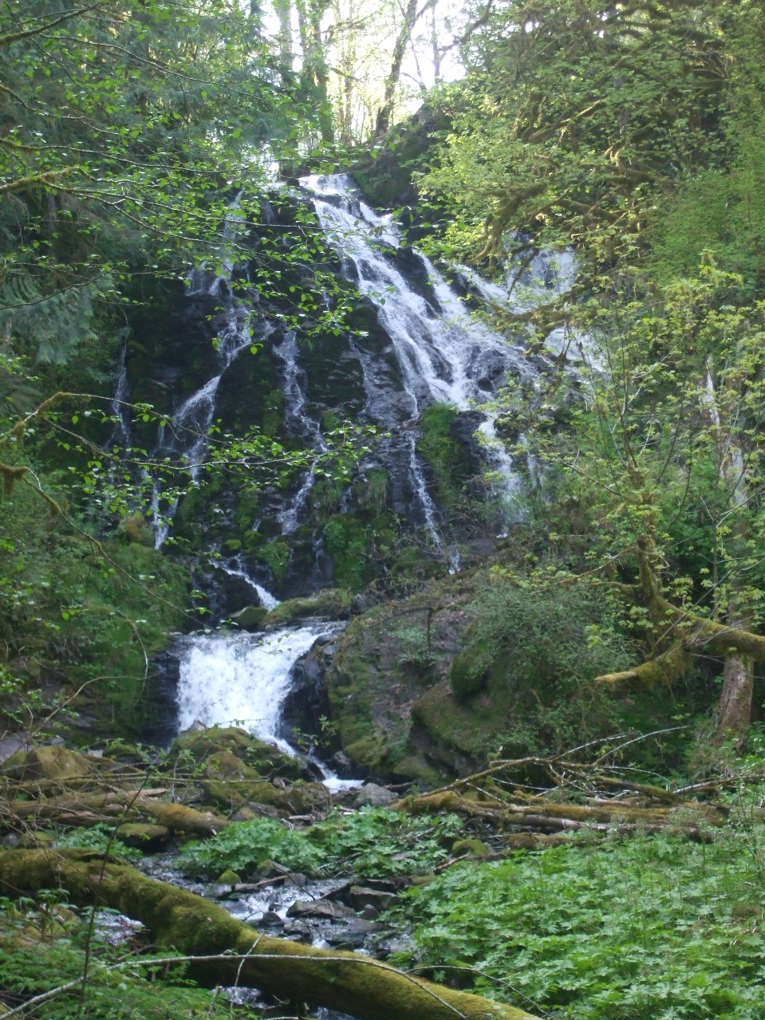
ADOPTED JULY 23, 2022
BOARD OF CLATSOP COUNTY COMMISSIONERS
- Mark Kujala, Chair (District 1)
- Lianne Thompson, Vice-Chair (District 5)
- John Toyooka (District 2)
- Pamela Wev (District 3)
- Courtney Bangs (District 4)
ELSIE-JEWELL CITIZEN ADVISORY COMMITTEE
- Pam Birmingham, Chair
- Susana Gladwin, Vice-Chair
- Don Abing
- Jody Abing
- Connie Moore
- Herb Olstedt
CLATSOP COUNTY PLANNING COMMISSION
- Nadia Gardner, Chair
- John Orr, Vice-Chair
- Christopher Farrar
- Cary Johnson
- Lam Quang
- Robert Stricklin (former member)
STAFF
- Don Bohn, County Manager
- Monica Steele, Assistant County Manager
- Julia Decker, Planning Manager
- Ian Sisson, Senior Planner
- Jason Pollack, Planner
- Victoria Sage, Planner
- Clancie Adams, Permit Technician
- Gail Henrikson, Community Development Director

Table of Contents
INTRODUCTION 2
LANDSCAPE UNITS 4
Shorelands 5
Alluvial Lowlands 5
Alluvial Terraces 5
Coast Range Foothills 5
Sedimentary Uplands 5
Basaltic Highlands 5
NATURAL RESOURCES 4
Forest Lands 5
Agricultural Lands 5
Water Resources 5
Fish and Wildlife 5
CRITICAL HAZARD AREAS 4
Flood Hazard 5
Shoreline Erosion 5
Mass Movement 5
Rock Fall 5
Wildfire 5
CULTURAL 4
Housing 5
Public Facilities and Services 5
Fire Protection 5
Transportation 5
Open Space, Recreation, and Preservation 5
COMMUNITY DEVELOPMENT 5
Development 5
Rural Lands 5
Forest Lands and Other Resources 5
Natural 5
GOALS, OBJECTIVES AND POLICIES 5
Index to Maps and Figures
MAP 1: Geologic Hazards 2
MAP 2: Special Flood Hazard Overlays 2
MAP 3: Special Districts 2
MAP 4: Open Space, Parks and Recreation 2

FIGURE 1: North Coast Basin 2
TABLE 1: Elsie-Jewell Planning Area – Drinking Water Systems 2
TABLE 2: Elsie-Jewell Planning Area – School Systems 2
TABLE 3: U.S. Highway 26 Traffic Volumes 2
TABLE 4: OR Highway 202 Traffic Volumes 2
TABLE 5: OR Highway 103 Traffic Volumes 2

INTRODUCTION
The approximately 178,600-acre Elsie-Jewell planning area is characterized by extensive areas in forest lands with some limited agricultural lands along the Nehalem River Valley. Residential development has occurred in various small pockets along the Nehalem River with some commercial activity in Jewell and along U.S. Highway 26 near Elsie and Elderberry. The timber within this planning area has historically provided the economic base for employment. Many residents within the area commute to employment centers in other areas of Clatsop County or to adjacent counties. As internet service improves within the Planning Area, it is likely that more residents will work remotely. This has and will continue to change the demographics of the Elsie-Jewell Planning Area.
The Clatsop County Comprehensive Plan has two parts: a Countywide Plan and six Community Plans. The Countywide Plan deals with state goals and programs of Countywide concerns such as the economy. Each Community Plan is an amplification of many of the County-wide policies which address specific concerns of the area. The Community Plans also addressed items not covered in the Countywide Plan because of an item's uniqueness to this particular area.
The original Elsie-Jewell Community Plan was adopted on July 23, 1980 (Ordinance 80-07). This plan, along with the community plan for each of the other five planning areas in Clatsop County is broken down into landscape units. Goals, objectives, policies and/or recommendations are provided for each of the landscape units. Additional sections in each community plan also include specific policies for the planning area related to the 18 statewide planning goals. Since originally adopted, the Elsie-Jewell Community Plan has been amended several times:
Elsie-Jewell Community Plan
- Ordinance 83-17: Amendments to address comments from the Department of Land Conservation and Development (DLCD)
- Ordinance 84-09: Amendments to address comments from DLCD
- Ordinance 84-10: Amendments to address comments from DLCD
- Ordinance 03-08: Amendments related to revised policies in Goal 7 and Goal 18
Taken together, the Plans provide a guide for development - whether it be residential, commercial, industrial or recreational. The intent of the Plan is NOT to stop or limit "rural" growth but rather to direct growth into appropriate locations while preserving the quality of life in the area. In looking at appropriate locations for various types of development, consideration was given to the preservation of resource lands (agricultural or forest lands), level of public facilities and services available, the land's carrying capacity, and the different needs for various uses within the planning area.
LANDSCAPE UNITS
Introduction
These landscape units should be evaluated and updated if needed based on input from the Oregon Department of Geology and Mineral Industries. The basic idea of the landscape unit is that is reflects a set of characteristics which, taken together, constitutes a natural process. The soils, hydrology, wildlife, vegetation, and land forms are interrelated as a functional unit. The landscape units provide a framework for development that is based on the land's capability. Each piece of land is in a landscape unit. The landscape units which occur in the Elsie-Jewell planning area are Shorelands, Alluvial Lowlands, Alluvial Terraces, Coast Range Foothills, Sedimentary Uplands and Basaltic Highlands. Map 1 shows their locations in the Elsie-Jewell planning area. These landscape units should be evaluated and updated if needed based on input from the Oregon Department of Geology and Mineral Industries.
Shorelands
Rivers, lakes and their shorelands are contained within this landscape unit. Within this planning area are the Nehalem and Necanicum Rivers and Lost Lake as well as many other smaller rivers, streams and tributaries.
Alluvial Lowlands
Alluvial lowlands are plains occupying valley floors which result from the deposition of clay, silt, sand and gravel by water. The alluvial lowlands are limited to the upper Necanicum Valley along the Sunset Highway with their most eastern reaches at the Necanicum Junction.
Alluvial Terraces
Alluvial terraces are relatively flat or gently sloping topographic surfaces which mark former valley floor levels. Stream down-cutting has caused the terraces to be higher than the present valley floor. The alluvial terrace deposits consist of gravel, sand, and finer material and are found primarily on the Nehalem River and along Beneke, Fishhawk, and Humbug Creeks.
Coast Range Foothills
Coast range foothills are low subsidiary hills on the edges of the coast range uplands. They range in elevation from 250 to 2,000 feet, and are generally composed of sedimentary rocks. The coast range foothills are located mainly to the east and adjacent to the Necanicum River as it flows behind Tillamook Head and along the lower Nehalem River.
Sedimentary Uplands
Sedimentary uplands consist of areas above the alluvial terraces, underlain chiefly by sedimentary rocks. Sedimentary uplands comprise almost the entire planning area, with the exception of several basaltic outcroppings. Sedimentary uplands are characteristically lower and/or more gradual slope than basaltic highlands, with elevation above 500 feet.
Basaltic Highlands
Basaltic highlands are underlain by igneous material. Most of the highlands are over 1,200 feet in elevation although outcrops of basalt are also exposed at lower elevations.
Basaltic highlands in this planning area are found in the southeastern quarter almost exclusively with several basaltic outcroppings in the northwestern areas, which include Saddle Mountain and Humbug Mountain. Generally, basaltic highlands are less gradual in their terrain and are located at higher elevations.

NATURAL RESOURCES
Forest Lands
Ownership of forest land has changed to a considerable degree during the past 70 years. Heavy cutting and the Great Depression brought much of the privately owned lands into County hands during the 1950's due to foreclosures. Approximately 29% of Clatsop County lands are publicly owned while over 200,000 acres are privately-owned by the timber industry.
Predominantly all forest lands in the planning area are either owned by Crown Zellerbach Corporation or the State Board of Forestry. However, there are several small woodlot holdings along the Nehalem Highway.
Agricultural Lands
Within this planning area, the best agricultural lands occur on the alluvium along the Nehalem River. Most of the agricultural lands are used for pasture at this time. . The entire Elsie-Jewell Planning Area is considered Major Big or Peripheral Big Game Habitat. The need to coexist with wildlife can create issues when elk, deer and other birds and animals compete for resources needed to supply livestock feed. Policies pertaining to forest and agricultural lands can be found in Goal 3 of the Countywide Plan Element of the Comprehensive Plan.
Water Resources
Per information from the Oregon Water Resources Department, nearly 23% of Oregonians rely on domestic wells, or private wells, as their primary source of potable water. This makes groundwater protection and well stewardship important to public health. ORS 448.271 requires sellers of property to test a well’s water quality and to share the result. Sellers are required to test for arsenic, nitrate, and total coliform bacteria. The major water resource is the Nehalem River, which traverses this area of the County. This river is used for both agriculture and recreation. Because of the sedimentary formations in this planning area, drilling for potable water is unpredictable always a gamble. Often when water is found in a well it is brackish. Drinking water comes from wells, springs, creeks and streams.
Per information from the Oregon Department of Environmental Quality (DEQ) the Elsie-Jewell Planning Area is located within the North Coast Basin, which extends from the Columbia River to the southern Tillamook County line (Figure 1). The basin consists of eight watersheds. Six watersheds drain to the Pacific Ocean:
- Necanicum
- Nehalem
- Tillamook Bay
- Nestucca
- Netarts/Sand Lake
- Neskowin
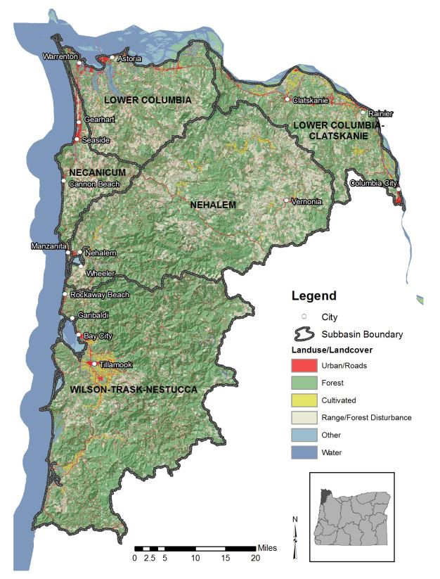
Two of the watersheds drain to the Columbia River:
Source: Oregon Department of Environmental Quality
FIGURE 1: NORTH COAST BASIN
The Nehalem and Salmonberry Rivers have been proposed by the Oregon Student Public Interest Research Group as potential scenic waterways. Within the State of Oregon Parks Six-Year Plan, only the Nehalem has been identified as a scenic waterway. For either of these rivers to become designated as a scenic waterway, studies will have to be done by Parks and Recreation and public hearings will have to be held. Upon the concurrence of the State Water Resources Board, the Transportation Commission may recommend to the Governor that a given river or river segment be designated by the Commission's recommendation as a Scenic Waterway. The Governor, however, is not bound to confer designation.
In 2019, a 17.5-mile portion of the Nehalem River between Henry Rierson Spruce Run Campground and the confluence with Cook Creek near cougar Valley State Park, was designated as an Oregon Scenic Waterway. Oregon Parks and Recreation Department is currently working with a Rules Advisory Committee to finalize river-specific rules for the designated stretch of river.
The County has designated most of the land along these rivers as CONSERVATION FOREST LANDS*, reflecting the predominant forest uses along most of the rivers. There is some land designated CONSERVATION OTHER RESOURCES land, reflecting recreation areas along the river*. The CAC strongly and emphatically opposes any suggestion that the Nehalem River be designated as "Scenic River."
Fish and Wildlife
The Nehalem River and many other streams and creeks provide excellent spawning habitats for anadromous fish. Anadromous fish such as salmon or steelhead hatch in upland freshwater streams migrate to sea to spend a major part of their life, and return to the freshwater upland stream to spawn a new generation of fish. Important to these streams is the maintenance of water quality and low turbidity levels.
Ruffled grouse, blue grouse, mountain quail, valley quail, and ring-necked pheasant are the most numerous and most hunted upland game birds in ODFW’s Harvest Area 1, which includes Clatsop County. The Planning Area supports a wide variety of bird species, including the band-tailed pigeon and species of traditional importance to the Clatsop Chinook. These species such as ravens, eagles, falcons, ospreys, hawks, owls, turkey vultures and the condor, represent the perpetuation of the circle of life. Maintaining a wide variety of vegetation is important, especially seed and fruit bearing plants. Reduced populations of upland game birds are probably the product of can be caused by chemical use of pest control manipulation of insects and vegetations, cumulative impacts of herbicides, insecticides and rodenticides, predator increases and habitat changes. Marbled murrelet, spotted owl and other endangered and threatened species are located in this area. None of the birds or animals within this planning area are considered endangered species at the present time. The Southwest Environmental Plan and the Fish and Wildlife Habitat Protection Plan for Clatsop County contains additional information.
With reference to big game, the Oregon Department of Fish and Wildlife classifies areas within the County as Major Big Game Range, Peripheral Big Game Range and Excluded Range.
*Amended 83-17, dated September 30, 1983.
1. Wildlife refuges:**
Existing wildlife refuges which are owned/leased and managed by the Oregon Department of Fish and Wildlife (ODFW) or by the United States Fish and Wildlife Service (USFWS) shall be designated Conservation-Other Resource and zoned Open Space, Parks and Recreation (OPR).
Proposed wildlife management areas which are managed and either owned or leased by the Oregon Department of Fish and Wildlife (ODFW) located in areas designated Conservation Forest or in other lowland areas under any plan designation shall be reviewed by the County for compliance with the approval standards listed below. Such hearings shall be conducted according to a Type IV procedure at a time and place convenient to residents of the affected planning area. ODFW shall provide an evaluation of the economic, social, environmental and energy consequences of the proposed and*** information sufficient to support findings with respect to the following approval criteria:
1. Identification of the need for the proposed new wildlife management area. "Need" means specific problems or conflicts that will be resolved or specific ODFW objectives that will be achieved by establishing the proposed area.
2. Alternative lands and management actions available to the ODFW, and an analysis of why those alternatives or management actions will not resolve identified problems or achieve objectives.

CRITICAL NATURAL HAZARD AREAS
Flood Hazard
Stream flooding in the Elsie-Jewell planning area does not occur as frequently as in the low, flat coastal and estuary areas, but can be just as severe. Severe flood events disrupt a significant portion of the population. Flood areas along the Nehalem River Valley are limited due to the narrow width of the valley. Most of the flood prone areas within the planning area have been put into either an agricultural or forest lands zones, restricting the density of residential development. Highway 103 and several local roads can be subject to flooding during heavy rain events. In February 1996, the heavy rains caused 16 rivers in northwest Oregon to flood, with eight inches of rain falling in one 24-hour period in the Coast Range. Dozens of homes were flooded and bridges such as the Vinemaple Bridge in the Elsie-Jewell Planning Area were impassable. A landslide on Lower Nehalem Road blocked the Nehalem River, which washed away two residences, that caused a logjam that destroyed the Sha-Ne-Mah bridge.
Clatsop County has participated in the National Flood Insurance Program since 1974. A floodplain ordinance was adopted in 1978 and continues to be in effect. In 2018, the County was required to update the floodplain ordinance when Flood Insurance Rate Maps (FIRMs) were updated for properties along the Pacific Ocean coast. On October 1, 2021, FEMA implemented its Risk 2.0 Insurance Mapping Program. This program is intended to revise flood insurance rates based not only upon a structure’s location to the Base Flood Elevation (BFE), but also to reflect the rebuild cost of the structures themselves. The revisions stem from a decades-long de facto subsidization of larger, higher-cost housing in flood-prone areas by smaller, lower-cost dwellings. The program will adjust flood insurance rates over a period of several years until property owners are paying the full amount of the costs to insure their buildings. This will result in a premium decrease for some property owners within the county, but may result in higher premiums for other property owners.

MAP 1: GEOLOGIC HAZARD AREAS
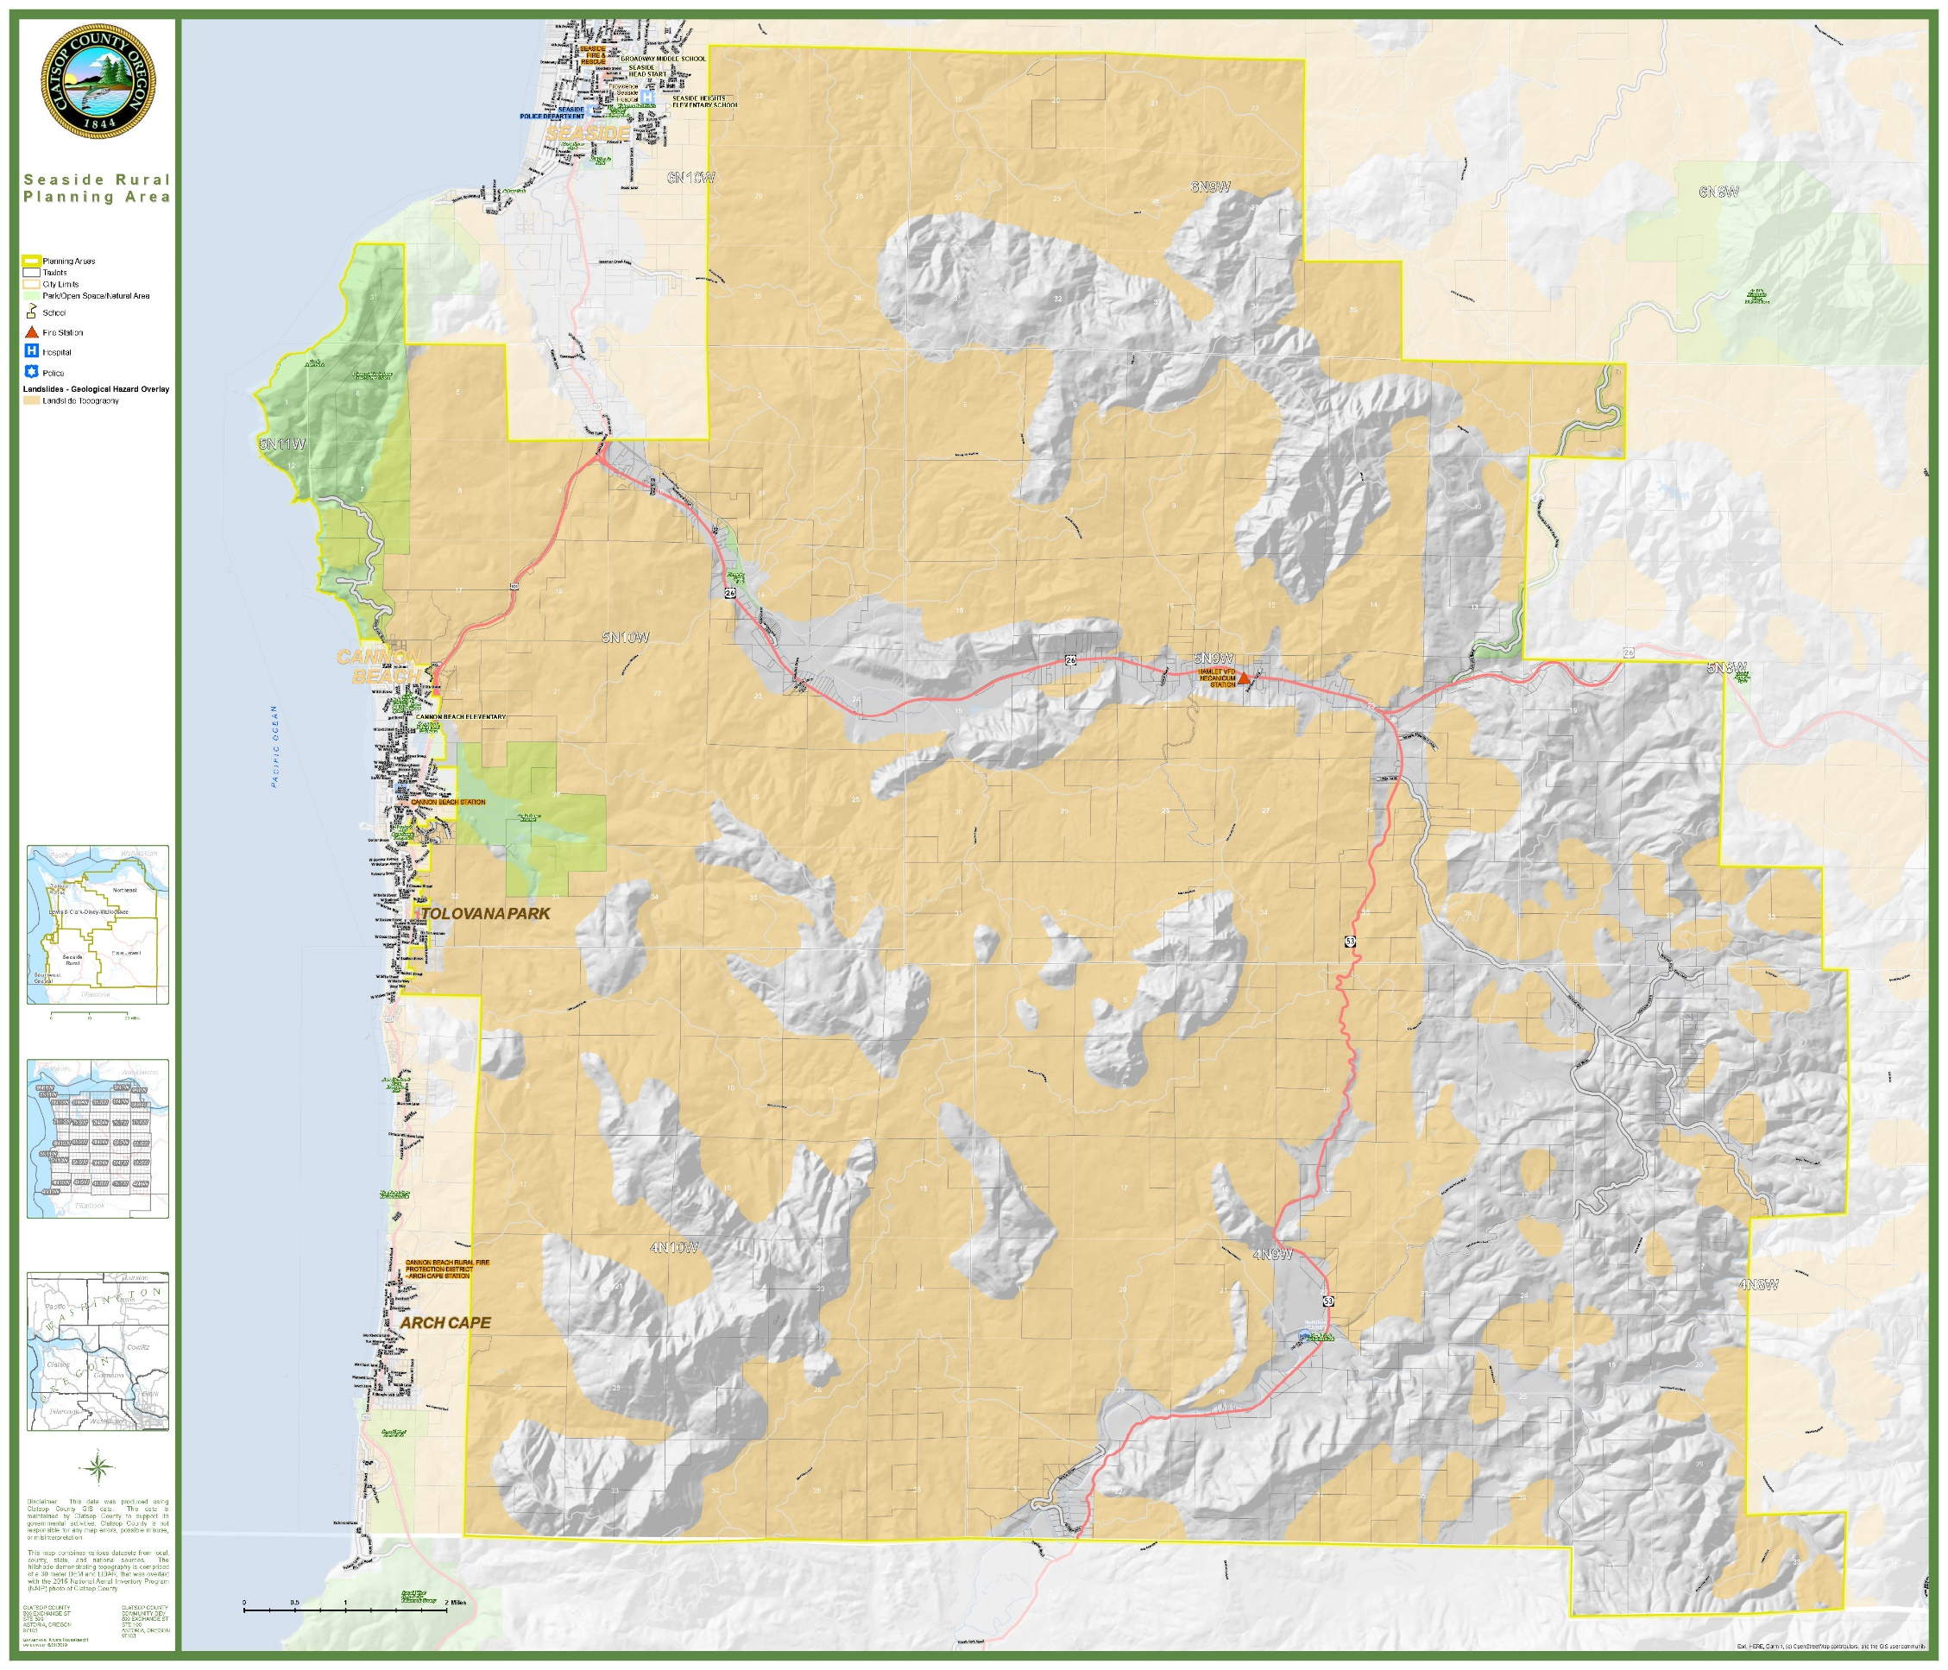

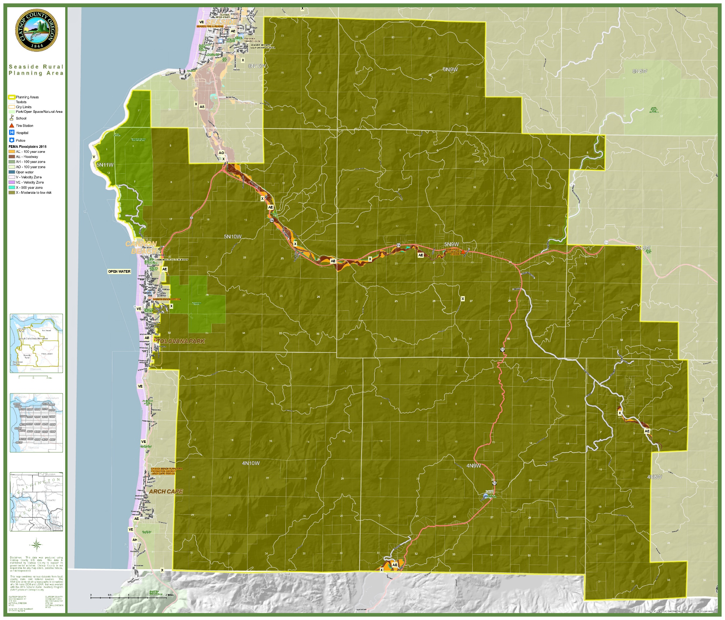
MAP 2: SPECIAL FLOOD HAZARD AREAS

Shoreline STREAM AND RIVER BANK Erosion
In most of the planning area, the natural shoreline has not been altered. Shoreline erosion is a natural process most evident where rivers bend. The upper portions of the Nehalem and the lower portions of the Humbug River have moderate streambank erosion problems. Moderate erosion causes some loss of land or partial interference with aquatic habitats.
*Amended 83-17, dated September 30, 1983.
**Amended 84-9, dated May 23, 1984.
***Amended 84-10, dated June 27, 1984.
Mass Movement
Within this planning area, extensive areas are subject to mass movement. While the majority of which area is in the forested interior, roads and residences are impacted by mass movement events. Major areas of mass movement are mostly forested areas designated CONSERVATION FOREST LANDS. Other low intensity uses such as dwellings, schools and small-scale commercial activities are also located within mass movement areas.*
The various types of hazards within the planning area are shown on Map 2, while policies for hazards are contained in Goal 7 of the Countywide Element of the Comprehensive Plan.
ROCK FALL
Along the State-maintained highways within the planning area, rock fall is a common occurrence. This hazard manifests itself by blocking roads or causing damage to vehicles.
Wildfire
Fire is an essential part of Oregon’s ecosystem, but it is also a serious threat to life and property particularly in the state’s growing rural communities. Wildfires are fires occurring in areas having large quantities of flammable vegetation. While wildfire risk has always existed throughout the state, previously, areas with the highest levels of risk were in central, southwest and northeast Oregon. With the changes being brought about by climate change, however, wildfire risk in the northwest is also increasing.
Because so many residential structures are in close proximity to timberlands, which may be more vulnerable to wildfires, hardening of existing residential structures should be encouraged. New construction on rural residential lands adjacent to forest resource land should be required to utilize hardening techniques and materials such as:
- Metal roofs and other fire-resistant roofing materials
- Fire-resistant siding
- Spark arresters on chimneys
- Screening of roof and foundation vents
Creation of defensible space should be encouraged based upon the best practices identified by the Oregon State University Extension Service . The County should work with the OSU Forestry and Natural Resources Extension Fire Program staff to review and adapt best practices from the Forest and Fire Toolkit, prepared by the Klamath Siskiyou Wildlands Center. Information from the FireWise plant list should also be made readily available to the public and use of those species should be encouraged. The County shall consider other sources of information as they become available.
TSUNAMI
While a tsunami will not directly affect the Elsie-Jewell Planning Area, it will have an impact on emergency services within the area as people evacuate out of tsunami inundation zones.
EARTHQUAKE / CASCADIA SUBDUCTION ZONE EVENT
While any high-magnitude earthquake will impact the planning area, a Cascadia Subduction Zone (CSZ) event is the most likely event to severely impact the Elsie-Jewell Planning Area. In the event of a CSZ event, this area will be isolated as roads and transportation systems will likely be severely damaged or destroyed. CERT volunteer training should be encouraged and cache areas and assembly points should be identified and developed. The County should promote education to ensure that residents and households are prepared to be self-sufficient for a minimum of two weeks in the event of a CSZ occurrence.
The Highway 26 bridge over Highway 103 is a continuing concern particularly with regard to flooding that might be caused by the bridge collapse during an earthquake.
Liquefaction
Liquefaction occurs when saturated soils substantially lose bearing capacity due to ground shaking, causing the soil to behave like a liquid. This in turn causes soils to lose their strength and their ability to support weight. The DOGAMI Natural Hazard Risk Report for Clatsop County conducted in 2018 built upon previous studies by the department and identified locations within the study area that are comparatively more vulnerable or at greater risk to CSZ M9.0 earthquake hazard. Because of the liquefaction, landslides, and bridge collapse, communities and structures on higher ground will likely be “islands” disconnected from other communities by severed transportation routes.

CULTURAL
Housing
Generally, the homes in the Elsie-Jewell planning area are older, with 62.6% of homes having been built before 1990. This equates to 502 dwellings out of the 802 residences located in the planning area..
Much of the housing is provided by manufactured dwellings. Because of the economic attractiveness of manufactured dwellings, this demand is expected to continue. Over the last 17 years, an average of 3 houses were built a year. This includes both stick-built homes and manufactured dwelling placements. Between 2005 and November 2021, a total of 51 permits were issued for the construction of new single-family and two-family homes. Despite its sparse population, housing continues to be challenge in this planning area, as well as throughout the County. In order to enhance recruitment, the Jewell School District has constructed several faculty dwellings on school property. In 2020, the District also constructed a quadraplex to provide local affordable housing for staff.
The 2020 Decennial Census detailed the population of the Jewell area as 1,068 residents, a 10-year increase of 2.5%. Demographic forecasts from the Population Research Center of Portland State University estimate that total population in the unincorporated areas of Clatsop County will decline by 510 residents by 2045. The forecast does not break down population estimates by planning area or unincorporated communities.
The adoption of SB 391 in 2021 would allow the County the ability to permit accessory dwelling units on rural residential lands. Appropriate requirements regarding wildfire interface standards are being developed. Once those standards have been adopted at the state level, the County should revise its code to allow ADUs in rural residential zones. The County should also review its current ADU size limitation to determine if larger ADUs should be allowed on rural residential lands. In the future, should the state legislature revise statutes to allow ADUs on resource lands, the County should consider similar code revisions.
Based upon the 2019 Housing Strategies Report, the County should review its non-residential non-resource zones to determine if inclusion of multi-family dwellings should be permitted.
New construction shall be encouraged to have a dedicated electric vehicle charging station.
Public Facilities and Services
Some of the statistics concerning public facilities are updated in the Goal 11 of the Countywide Element of the Comprehensive Plan.*
Sewer Systems
Per information from the Oregon Department of Environmental Quality (DEQ) within this planning area, water quality permits have been issued by the state for onsite sewage facilities to the following entities:
- ODOT – Sunset Springs Safety Rest Area
- Jewell School District #8
- Fishhawk Lake Reserve and Community

Community Water Systems
Most of the people in the Elsie-Jewell planning area obtain their water from wells or springs. There are, however, several community water systems in the area, as noted on Table 1, below
*Amended 83-17, dated September 30, 1983.
The Elderberry Nehalem’s Water System has had numerous complaints by users on the water quality and pressure of the system. This system serves approximately 140 persons and two businesses.
TABLE 1: ELSIE-JEWELL PLANNING AREA - DRINKING WATER SYSTEMS
System | Number of Connections | Estimated Total  Population Served | Existing Source and  Water Rights | Current Violations
Camp 18 | 5 | 69 | Groundwater | No
Elderberry Nehalem | 60 | 140 | Groundwater | Yes
Evergreen Acres | 47 | 100 | Groundwater | Yes
Fishhawk Lake | 250 | 350 | Surface Water | Yes
Hamlet Quick-Stop | 1 | 30 | Surface Water | No
Jewell School District #8 | 10 | 200 | Groundwater under the direct influence of surface water | No
ODF Northrup Creek Horse Camp | 1 | 55 | Groundwater | No
ODF Spruce Run Park | 1 | 40 | Groundwater | Yes
ODOT Sunset Springs Rest Area | 3 | 500 | Groundwater | No
Oney’s Restaurant and Lounge | 6 | 60 | Groundwater | No
Source: Oregon Health Authority
Schools
The Elsie-Jewell planning area lies primarily within the Jewell School District #8. Portions of the northwest quadrant of the planning area are within Astoria School District #1 and portions of the southwest quadrant are within Seaside School District #10. The Jewell Consolidated School District covers the whole planning area, providing provides education from Kindergarten through 12th grade. The Jewell school also serves as a de facto community center due to the lack of other community buildings within the planning area. Enrollment as of 1979 at the Jewell School was 115 with a design capacity of approximately 250 students.

TABLE 2: ELSIE-JEWELL PLANNING AREA – SCHOOL SYSTEMS
System | Seaside School District #10 |  |  |  | Jewell School District #8 | Astoria School District #1
 | Pacific Ridge Elementary | Seaside Middle School | Seaside High School | Cannon Beach Academy Charter School | Jewell School | John Jacob Astor Elementary | Lewis and Clark Elementary | Astoria Middle School | Astoria High School
Grades | K-5 | 6-8 | 9-12 | K-5 | K-12 | K-2 | 3-5 | 6-8 | 9-12
Enrollment | 654 | 374 | 427 | 45 | 114 | 357 | 424 | 433 | 562
Capacity | 630 | Unavailable | 450 | 75 | 00 | 880 | 960 | 1,360 | 1,320
Year Built | 2003 | 2020 | 2020 | 1977 | 2007 | 1922 | 2002 | 1968 | 1957
Source: Oregon Department of Education, 2020-21 At-A-Glance School Profiles; Clatsop County Assessment and Taxation

MAP 3: SPECIAL DISTRICTS
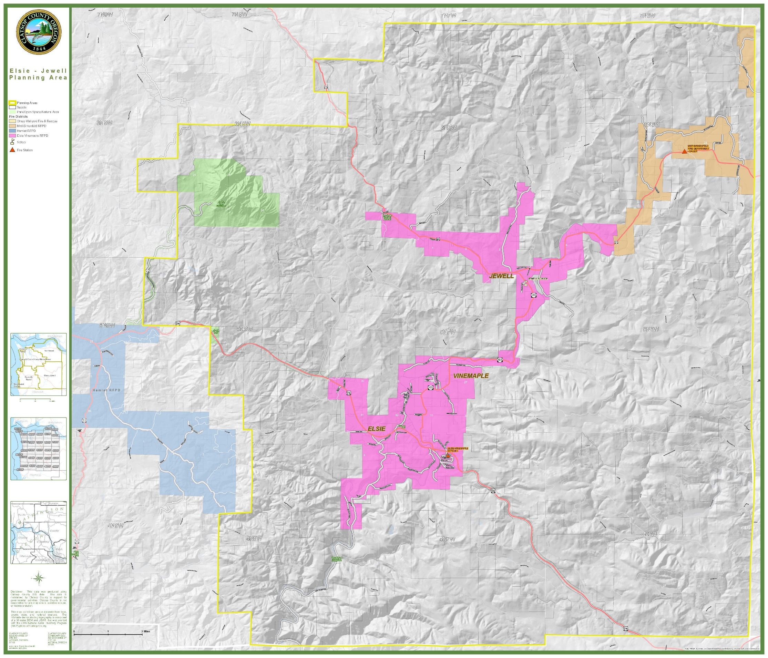

Fire Protection
Fire protection is provided by Elsie-Vinemaple Rural Fire Protection District, Mist-Birkenfeld Rural Fire Protection District, and State Forestry. With the formation of the District in 1978, fire insurance premiums for residences dropped approximately 20 to 30%. State Forestry provides fire protection to forest land only and does not have the training nor equipment to put out fires in burning structures. Mutual aid agreements with surrounding fire districts and departments, including Hamlet and Banks, provide additional resources to the planning area.
Transportation
The automobile and truck are the predominant means of moving people and goods within this planning area. U.S. Highway 26 is one of the two major links between the Portland metropolitan area to the northern Oregon coast. As the use of electric vehicles becomes more prevalent, a public electric vehicle charging station should be located within the planning area.
Highway 103, which connects Highway 202 with Highway 26, has become a bypass to traffic congestion on Highway 26, utilized both by residents and by visitors to the coast. The Oregon Department of Transportation maintains four major roads within the planning area:
- Highway 202 (Necanicum Highway)
- Highway 26 (Sunset Highway)
- Highway 103 (Fishhawk Falls Highway)
- Highway 53 (Nehalem Highway)
In the months immediately following March 2020, traffic suddenly decreased as COVID-19 pandemic lockdowns and/or service curtailments were implemented. Table 1 details Average Annual Daily Traffic Counts (AADT) on selected segments of U.S. Highway 101 in and adjacent to the Clatsop Plains Planning Area. Traffic data for 2021 was not available at the time this plan was update. It is likely, however, that 2021 traffic volumes will have increased to at least 2019 levels.
As opportunities and technology have increased to support remote work options, traffic patterns may be altered accordingly.
TABLE 3: U.S. HIGHWAY 26 TRAFFIC VOLUMES (2018-2020)
 | AADT*
ROAD SEGMENT | 2020 | 2019 | 2018
0.70 Miles East of Oregon Coast Highway (U.S. 101) | 7,649 | 8,500 | 8,500
Black Bridge | 6,715 | 7,400 | 7,500
0.05 Miles East of Necanicum Highway (OR 53) | 6,806 | 7,500 | 7,600
0.02 Miles East of Saddle Mountain Road | 7,144 | 7,900 | 8,000
0.05 Miles West of Fishhawk Falls Highway | 6,963 | 7,700 | 7,800
Clatsop-Tillamook County Line | 6,483 | 7,200 | 7,200
*AADT: Average Annual Daily Trips
Source: Oregon Department of Transportation, State Highway Traffic Volumes
TABLE 4: OR HIGHWAY 202 TRAFFIC VOLUMES (2018-2020)
 | AADT*
ROAD SEGMENT | 2020 | 2019 | 2018
0.02 Miles West of Williamsport Road | 3,240 | 3,600 | 3,600
Walluski River Bridge | 2,549 | 2,800 | 2,800
0.10 Miles North of Walluski Loop Road | 1,604 | 1,800 | 1,800
0.03 Miles South of Walluski Loop Road | 1,499 | 1,700 | 1,700
0.02 Miles East of Youngs River Loop Road | 860 | 950 | 960
0.02 Miles west of Norlund-McCoy Road | 612 | 680 | 680
Hamilton Creek Bridge | 327 | 360 | 370
0.02 Miles West of Beneke Road | 367 | 410 | 410
0.02 Miles West of Fishhawk Falls Highway at Jewell | 382 | 420 | 430
0.05 Miles East of Fishhawk Falls Highway at Jewell | 511 | 570 | 570
Nehalem River Bridge | 496 | 550 | 550
Clatsop-Columbia County Line | 405 | 450 | 450
*AADT: Average Annual Daily Trips
Source: Oregon Department of Transportation, State Highway Traffic Volumes
TABLE 5: OR HIGHWAY 103 TRAFFIC VOLUMES (2018-2020)
 | AADT*
ROAD SEGMENT | 2020 | 2019 | 2018
0.05 Miles South of Nehalem Highway (OR 202) | 594 | 660 | 660
0.20 Miles South of Meadow Lane | 587 | 650 | 660
Vinemaple Bridge | 654 | 730 | 730
0.02 Miles East of Cow Creek Road | 684 | 760 | 760
0.02 Miles South of Bay Road | 907 | 1,000 | 1,000
0.05 Miles North of Sunset Highway (U.S. 26) | 999 | 1,100 | 1,100
*AADT: Average Annual Daily Trips
Source: Oregon Department of Transportation, State Highway Traffic Volumes
Open Space, Recreation and Preservation HISTORIC RESOURCES
Open space exists through a wide variety of different land uses as shown by the following categories:
Categories Examples
Resource lands Forest lands
Recreation Fishhawk Lee Wooden Falls Park
Scenic/Buffer Open space within a subdivision
Preservation Elsie Park

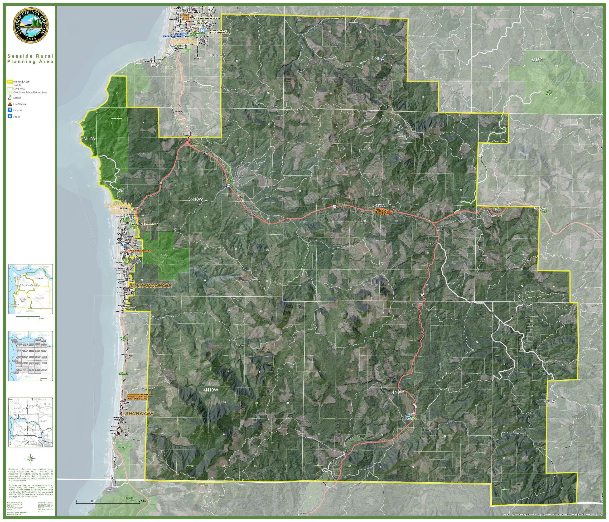
MAP 4: OPEN SPACE, PARKS AND RECREATION

Map 3 shows the location of the various types of open space within the planning area. The most dominant form of open space in this planning area is the extensive areas in forest lands.
The following discussion and policies are in addition to those found in the Goal 5: Open Space, Scenic and Historic Areas and Natural Areas and Recreational Needs Element. Sites inventoried in this section that are in addition to those inventoried in the Open Space and Recreational Needs Elements are local desires and are not to be construed as additional Goal site requirements.*
Recreation
Recreation facilities for the public are provided at Saddle Mountain State Park, as well as at the four County parks (David Douglas, Fishhawk Falls (Lee Wooden) Park, Spruce Run Park) and sports facilities at the Jewell School. Private facilities exist at Sports Acres which has cabins and various types of sports activities available to members.
Preservation Historic Resources
The Clatsop County Historical Advisory Committee, under the direction of the Clatsop County Board of Commissioners, prepared a map of various historical sites within the County in 1976. This area of the County is rich in history. Predominantly all of the historical sites in this planning area represent the occurrence of a historical event and may be appropriate for historical signing as funds become available. Some of the local residents are interested in turning the Jamieson House at the Jewell Wildlife Meadows into a historical museum with snack bar and restroom facilities. Provisions have been made in the Plan for this should it occur.
Other aspects of preservation are the various Natural areas which play a crucial role in the rapidly changing landscape. Most important, perhaps, is that they serve as benchmarks for assessing the extent of man's human impact upon diverse land, lakes, rivers, estuary and coastal environments.
The Nature Conservancy through the Oregon Natural Heritage Program was commissioned by the State of Oregon to provide an inventory of potential natural areas, natural area needs, and programs to protect natural areas. Below is a list of potential natural areas inventoried within this planning area and how they are to be managed. Several of the areas identified need further research to better determine their location, boundaries, and consequences of alternative decisions.
*Amended 83-17, dated September 30, 1983.
Site
David Douglas Park These three parks are designated
Elsie Park CONSERVATION OTHER RESOURCES and
Saddle Mountain Park will be placed in the Open Space, Recreation and Parks zone which is not in conflict with the recommended use.*
Four County Corners All of these areas have been
Walker Creek Old Growth designated CONSERVATION FOREST
Lost and Spruce Run Lakes LANDS. The conflict use occurs
Flat Iron Mountain between Goal 4, Forest Lands and
McGregor and Goal 5, Open Space, Scenic
Northrup Creek and Natural Resources in restricting forest uses and activities. See Clatsop County's Open Space, Scenic and Historic Areas and Natural Resources Element for discussion and resolution of conflicts.*
Nehalem River In both these areas, the State of
Fall Creek Falls Oregon Forestry Department is the predominant property owner. In the Fall Creek Falls area, 20-30 acres has been classified by the Forestry Department as scenic conservancy, while along the Nehalem River, 168 acres has been classified as scenic conservancy. See Open Spaces, Scenic and Historic Areas and Natural Resources Element for discussion and resolution of conflicts.

The Ed Wilson Farm is managed by the State Fish and Wildlife Commission for elk wintering range. The area has been designated FOREST LANDS and has been zoned for forest zones. Conflicts occur here and at the Jewell Wildlife Meadows between the elk and farm and forest uses.
Beneke Creek is a wildlife habitat for elk. This area has been designated CONSERVATION OTHER RESOURCES and has been zoned Open Space, Recreation, and Parks. Due to the conflicts with the elk, new or expansion of existing wildlife management areas are a review use.
Jewell Wildlife Meadows area has been designated CONSERVATION OTHER RESOURCES and will be placed in the Open Space, Recreation, and Parks zone. Due to the conflicts with the elk, new or expansion of existing wildlife management areas will be a review use.*
*Amended 83-17, dated September 30, 1983.

COMMUNITY DEVELOPMENT
Clatsop County has identified six different land use types that form the basis for the zoning designations applied to all properties within the unincorporated area. In the discussion of the planning process, a brief explanation was given on the Classification System (DEVELOPMENT, RURAL LANDS*, RURAL AGRICULTURAL LANDS*, CONSERVATION FOREST LANDS*, CONSERVATION OTHER RESOURCES*, and NATURAL) to be used on the Comprehensive Plan Map. This section of the Plan goes into greater detail in describing the designations, their objectives and policies pertaining to the designations.
DEVELOPMENT
Areas designated DEVELOPMENT are areas with a combination of physical, biological, and social/economic characteristics which make them necessary and suitable for residential, commercial, or industrial development and includes those which can be adequately served or planned urban services and facilities.
Areas within Urban Growth Boundaries and Rural Service Areas are included within this designation. There are no Urban Growth Boundary designations for this planning area.
Rural Service Area is an unincorporated area located some distance away from a city and contains residential densities similar to those found in cities. The size of Rural Service Areas is based upon many factors, some of which are:
- population projections
- capacity of public facilities
- , and proximity to a city.
Fishhawk Lake Estates is an area which meets the criteria for Rural Service Area (RSA). This area was developed in 1967 as a recreational community. A community sewer and water system, as well as roads, have been developed to provide for future housing.
This area was developed in 1967 as a recreational community which currently has 15 permanent residences and 38 seasonal residences.
Predominant Uses in the Development land use classification include:
1. Medium to high density single family houses (less than 1 acre).
2. Multi-family housing (apartment, mobile home parks).
3. Offices, commercial facilities.
4. Industrial facilities (light/heavy).
*Amended 83-17, dated September 30, 1983.
RURAL LANDS*
RURAL lands are those lands which are outside the urban growth boundary and are not agricultural lands or forest lands. Rural lands include lands suitable for sparse settlement, small farms or acreage homesites with no or hardly any public services, and which are not suitable, necessary or intended for urban use.*
*Amended 83-17, dated September 30, 1983.
Rural lands are those which, due to their value for aquaculture, low density residential uses, high intensity recreational uses, and non-renewable mineral and non-mineral resource uses should be protected from conversion to more intensive uses. Rural subdivisions, major and minor partitions, and other uses served by few public services which satisfy a need that cannot be accommodated in urbanizable areas are also likely to occur within this designation.*
Most Rural Lands designated in this Plan are in areas which contain old town plats and fragmented land ownerships. These areas may require vacation and replatting or utilization of a Planned Development to protect the natural resources of the area.
RURAL AGRICULTURAL LANDS
Agricultural Lands are those lands that are to be preserved and maintained for farm use, consistent with existing and future needs for agricultural products, forest and open space.*
In land use changes involving a change from Conservation Forest Lands or Rural Agricultural Lands to Rural Lands or Development designations an Exception to the Agricultural Lands or Forest Lands Goals must be taken.
Within this planning area, there is approximately 150 acres in the Jewell area zoned for light industrial uses. The people in the area feel additional areas are needed in the future. During the update of this community plan, committee members also expressed a desire to allow additional types of home occupations that would provide needed services to local residents. Members, however, also expressed concerns about unpermitted home occupations and the need to monitor certain types of businesses, such as automobile repair, in order to protect the environment and the neighborhood from negative impacts. Businesses that do not impact the environment or surrounding neighborhoods are encouraged. In developing the zoning, however, the Citizen Advisory Committee (CAC) and County were unable to identify additional properties for light industrial uses. The County will facilitate Comprehensive Plan and zone changes for light industrial proposals in appropriate areas, considering such items as their compatibility with the surrounding area.
Predominant Uses in the Rural Agricultural Lands classification include:
1. Farm use. (see Goal 3: Agricultural Lands Background Report and County-wide Element).*
2. Low density residential (1 acre or larger).
3. Commercial (gas station, grocery store).
4. High intensity recreation (i.e. golf course).
CONSERVATION FOREST LANDS AND OTHER RESOURCES*
CONSERVATION FOREST LANDS AND OTHER RESOURCES. Conservation areas provide important resource or ecosystem support functions but because of their value for low-intensity recreation or because of their unsuitability for development (i.e. hazard areas) should be designated for non-consumptive uses. Non-consumptive uses are those uses which can utilize resources on a sustained yield basis while minimally reducing opportunities for other future uses of the area's resources.*
*Amended 83-17, dated September 30, 1983.
CONSERVATION Forest Lands
Forest Lands are those lands that are to be retained for the production of wood fiber and other forest uses.*
In land use changes involving a change from Conservation Forest Lands or Rural Agricultural Lands to Rural Lands or Development designations, an Exception to the Agricultural Lands or Forest Lands Goals must be taken.**
Conservation Other Resources
Conservation Other Resources areas provide important resource or ecosystem support functions such as lakes and wetlands and federal, state, and local parks. Other areas designated CONSERVATION OTHER RESOURCES include lands for low intensity uses which do not disrupt the resource and recreational value of the land.*
Predominantly all the lands in this planning area are designated as CONSERVTAION FOREST LANDS and have been will be placed in one of the forest zones developed by the County. Saddle Mountain State Park, David Douglas Park, Elsie Park, Fishhawk Falls Park and Spruce Run Park are designated CONSERVATION OTHER RESOURCES and zoned for Open Space, Recreation and Parks or Recreation Management.*
Predominant Uses in the Forest Lands classification and Conservation Other Resources Classification include:
1. Forestry/forest processing (see Goal 4: Forest Lands Background Report and County-wide Element).*
2. Farming.
3. Parks and scenic areas.
4. Small woodlots.
5. Community watersheds.
NATURAL
A NATURAL area is defined as land and/or water units in which natural processes exist relatively undisturbed or can be restored to a nearly natural state. Natural areas include:
*Amended 83-17, dated September 30, 1983.
**Amended 84-9, dated May 22, 1984.
Predominant Uses in the Natural land use classification include:
1. Open space.
2. Scientific study.
3. Low intensity recreation (trails, nature observation).
4. Wildlife habitat.

GOALS, OBJECTIVES AND POLICIES
Shorelands Policies
Policy 1: Culverts and other roadway or driveway improvements shall be installed in such a manner as not to impede the flow of the drainage way and not impede the passage of fish.
Policy 2: Drainage and/or filling portions of lakes shall be discouraged.
Policy 3: Consideration shall be given to protection of the lakes from further degradation (eutrophication), and possible remedial actions to improve water quality.

ALLUVIAL LOWLANDS Policies
Policy 1: Development on peat and other compressible soils are required to be engineered.
Policy 2: Low density activities shall be preferred uses in the alluvial lowlands.

ALLUVIAL TERRACES PolicY
Policy 1: The County should encourage development on this type of landscape unit due to the slight to moderate slopes and the moderately well-drained soils.

COAST RANGE FOOTHILLS PolicY
Policy 1: The predominant land use on this landscape unit is forestry. This is due to the characteristics of soils in this landscape unit which have slide potential on slopes and are highly suited for timber production.

SEDIMENTARY UPLANDS PolicY
Policy 1: The sedimentary uplands should be reserved primarily for timber production, water supply protection, and wildlife habitat.

BASALTIC HIGHLANDS PolicY
Policy 1: The highlands should be designated a resource unit, and uses other than woodland, wildlife habitat, recreation, and natural and mineral resources shall be discouraged.

NATURAL RESOURCES POLICIES – WATER RESOURCES
Policy 1: The County should encourage water storage/holding tanks/catchment systems for new residential and commercial development within the planning area.
Policy 2: In order to ensure that the County is not requiring surplus capacity to serve development, the County should review its minimum water flow requirements to ensure that its requirements are consistent with actual usage patterns. Required water flow should be based on the number of fixtures and/or house size.
Policy 3: The County shall encourage new innovation and concepts to conserve and/or reduce water usage including, but not limited to grey water recycling, as permitted under OAR 340-053, which was approved in Oregon in 2012.

Policy 4: The County should conduct an ESEE analysis in the next 2-5 years following adoption of this plan for Fishhawk Creek to determine whether additional protections are needed.

NATURAL HAZARDS POLICY – GENERAL
Policy 1: The County shall promote education to ensure that households are prepared to be self-sufficient for a minimum of two weeks as natural disasters can leave residents in the Seaside Rural Planning Area isolated.
NATURAL HAZARDS POLICY – Stream and river bank erosion
Policy 1: Prevention of stream and river bank erosion caused by development shall be considered during the permitting process.
Policy 2: The County shall encourage the use of native vegetation to stabilize stream and river banks.
NATURAL RESOURCES POLICIES – EARTHQUAKES / CASCADIA SUBDUCTION ZONE EVENT
Policy 1: CERT volunteer training should be encouraged and cache areas and assembly points should be identified and developed.
Policy 2: The County shall promote education to ensure that residents and households are prepared to be self-sufficient for a minimum of two weeks in the event of a CSZ occurance.
NATURAL HAZARDS POLICY – WILDFIRE
Policy 1: The County should develop hardening standards for new construction in wildfire risk areas. For example, require spark arresters, metal roofs, fire retardant siding, and vegetative clearing.
Policy 2: Hardening of existing residential structures should be encouraged.
Policy 3: New construction on rural residential lands adjacent to forest resource land should be required to utilize hardening techniques and materials .

Policy 4: Creation of defensible space should be encouraged based upon the best practices identified by the Oregon State University Extension Service .
Policy 5: The County should work with the OSU Forestry and Natural Resources Extension Fire Program staff to review and adapt best practices from the Forest and Fire Toolkit, prepared by the Klamath Siskiyou Wildlands Center.
Policy 6: Information from the FireWise plant list should be made readily available to the public and use of those species should be encouraged.
Policy 7: The County shall consider other sources of information as they become available.
Policy 8: The County shall encourage signage promoting fire safety along County roads.

HOUSING POLICIES
Policy 1: The location of a manufactured home on an individual parcel of land shall be allowed in all areas.
Policy 2: The County should work to reduce barriers to permitting accessory dwelling units on rural residential lands to the greatest extent possible.
Policy 3: Once the SB 391 standards have been adopted at the state level, the County should revise its code to allow ADUs in rural residential zones.
Policy 4: The County should review its current ADU size limitation to determine if larger ADUs should be allowed on rural residential lands.
Policy 5: In the future, should the state legislature revise statutes to allow ADUs on resource lands, the County should consider similar code revisions.
Policy 6: Based upon the 2019 Housing Strategies Report, the County should review its non-residential non-resource zones to determine if inclusion of multi-family dwellings should be permitted.
Policy 7: New construction shall be encouraged to have a dedicated electric vehicle charging station.

TRANSPORTATION POLICY
Policy 1: When the State Department of Transportation improves U.S. Highways 101, 26, 53, and 202, consideration should also be given to provision of a safe bikeway, suitable crosswalks, fog lines and the installation of curbing to separate the auto traffic where possible.

RECREATION POLICY
Policy 1: The County will work to identify and establish public access facilities along the main stem of the Nehalem River.
Policy 2: The County shall identify opportunities for additional recreational facilities and types of recreation.

OPEN SPACE, RECREATION AND PRESERVATION HISTORIC RESOURCES POLICY
Policy 1: The use of identifying signs for historic and cultural landmarks shall be encouraged. The Clatsop County Historical Society should shall be encouraged to assist in this project.

CULTURAL AREAS POLICY
Policy 1: Information regarding inadvertent discoveries of human remains, cairns, village sites, artifacts and indigenous encampments should be reported to the Chinook Indian Nation and the State Historic Preservation Office.

COMMUNITY DEVELOPMENT OBJECTIVES AND POLICIES – DEVELOPMENT LAND USE CLASSIFICATION
Objective 1: To ensure optimum utilization of urban and urbanizable lands and to provide for an orderly and efficient transition from rural to urban land use.
Objective 2: To encourage development in this area to relieve the need for development in other areas.
Objective 3: To encourage the location of public and private facilities and services so that they do tend to attract residential development to locations inside DEVELOPMENT areas.
Objective 4: To avoid the extension of urban services (i.e. sewer systems) into outlying sparsely settled areas (1 acre or greater sites).
Rural Service Area Policy 1: Changes in the Rural Service Area boundary shall be done only after the following factors are considered:
- there is demonstrated need to accommodate long range urban population growth requirements;
- there is a need for housing, employment opportunities, and livability;
- the change would provide an orderly and economic extension of public facilities and services;
- the change would allow for efficient land use and utility patterns within and on the fringe of the existing urban area;
- the environmental, energy, economic and social consequences of the proposed area

COMMUNITY DEVELOPMENT OBJECTIVES AND POLICIES – RURAL LANDS CLASSIFICATION
Objective 1: To preserve the rural character of uplands and woodland areas, and maintain open spaces and opportunities along the shoreline for recreational uses compatible with low density residential activity.
Objective 2: To retain rural areas as spare settlement, small farms or acreage homesites with hardly any public services.
Objective 3: To maintain the open spaces between various types of development so as to preserve the rural character of the area.
Objective 4: To provide for housing types (i.e. acreage homesites) which cannot be accommodated in cities, urban growth boundaries or Rural Service Areas.
Policy 1: Rural residential lot sizes shall be based upon the public facilities available, compatibility with surrounding uses, and land carrying capacity. Generally, those areas within a fire protection district and community water system should be zoned with a minimum lot size of one (1) acre, while other areas with only a fire district or community water system should be zoned with a minimum lot size of two (2) acres, and those RURAL LANDS* areas without facilities should be zoned with a minimum lot size of five (5) acres.
Policy 2: In order to avoid dispersal of commercial activities, new commercial zones shall only be considered if they are of a neighborhood type or are concentrated in and adjacent to existing well-established areas.
Policy 3: When considering new commercial areas or expansion of existing commercially zoned land, the following standards shall be used:
- Adequate off-street parking shall be provided to prevent traffic congestion resulting from on-street parking.
- A buffer and screen shall be provided between commercial and residential uses.
- Signs shall be designed so as not to disturb from the surrounding area.
- The size of neighborhood commercial uses shall be sized to serve every day personal needs of the surrounding rural population and generate little or no traffic from outside of the rural area.

COMMUNITY DEVELOPMENT OBJECTIVES AND POLICIES – NATURAL LAND USE CLASSIFICATION
Objective 1: To preserve, restore and protect these areas for scientific, research and education needs and for the resource and ecosystem support values and functions they provide.

COORDINATING STATE AGENCIES:
Oregon Department of Fish and Wildlife (ODFW)
Oregon Department of Agriculture (ODA)
Oregon Parks and Recreation Department (OPRD)
Oregon Department of Energy (ODOE)
State Historic Preservation Office (SHPO)
Oregon Department of State Lands (DSL)
Oregon Health Authority (OHA)
Department of Geology and Mineral Inventories (DOGAMI)
Oregon Department of Land Conservation and Development (DLCD)

BACKGROUND REPORTS AND SUPPORTING DATA:
2021 Oregon Distribution System Plan, PacifiCorp

